**Name: Krishna Pandey**

**Admission no: U20CS110**

**DIGITAL ELECTRONICS AND LOGIC DESIGN [EC - 207]**

**SARDAR VALLABHBHAI NATIONAL INSTITUTE OF TECHNOLOGY, SURAT ELECTRONICS ENGINEERING DEPARTMENT**

**APPLICATION OF OP-AMP CIRCUITS**

AIM: - To implement various OP-AMP circuits and verify application of them using multi-Sim simulator.

SOFTWARE TOOLS / OTHER REQUIREMENTS: - (1). Multisim Simulator/Circuit Simulator.

THOERY: -

An operational amplifier or op-amp is simply a linear Integrated Circuit (IC) having multiple-terminals. The op-amp can be considered to be a voltage amplifying device that is designed to be used with external feedback components such as resistors and capacitors between its output and input terminals. It is a high-gain electronic voltage amplifier with a differential input and usually a single-ended output. Op-amps are among the most widely used electronic devices today as they are used in a vast array of consumer, industrial and scientific devices The inner schematic of a typical operational amplifier looks like this.

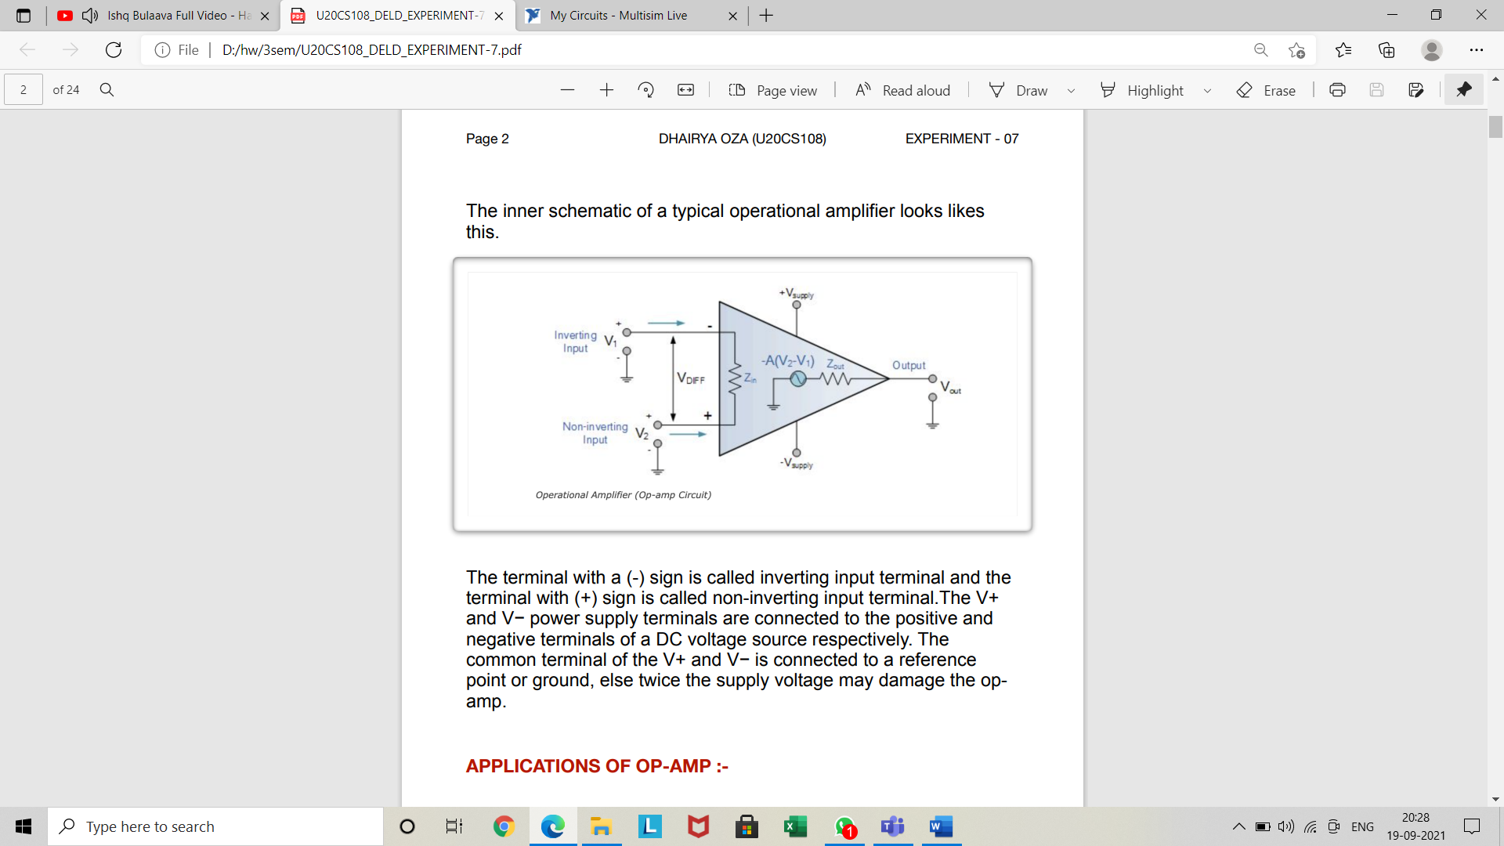

The terminal with a (-) sign is called inverting input terminal and the terminal with (+) sign is called non-inverting input terminal. The V+ and V− power supply terminals are connected to the positive and negative terminals of a DC voltage source respectively. The common terminal of the V+ and V− is connected to a reference point or ground, else twice the supply voltage may damage the opamp.

APPLICATIONS OF OP-AMP: -

1. **ADDER :-**

An adder is an electronic circuit that produces an output, which is equal to the sum of the applied inputs. This section discusses about the op-amp based adder circuit. An op-amp based adder produces an output equal to the sum of the input voltages applied at its inverting terminal. It is also called as a summing amplifier, since the output is an amplified one.

The circuit diagram of an op-amp based adder is shown in the following figure –

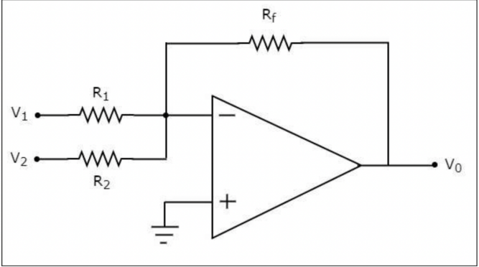

In the above circuit, the non-inverting input terminal of the op-amp is connected to ground. That means zero volts is applied at its noninverting input terminal. According to the virtual short concept, the voltage at the inverting input terminal of an op-amp is same as that of the voltage at its non-inverting input terminal. So, the voltage at the inverting input terminal of the op-amp will be zero volts.

The nodal equation at the inverting input terminal's node is

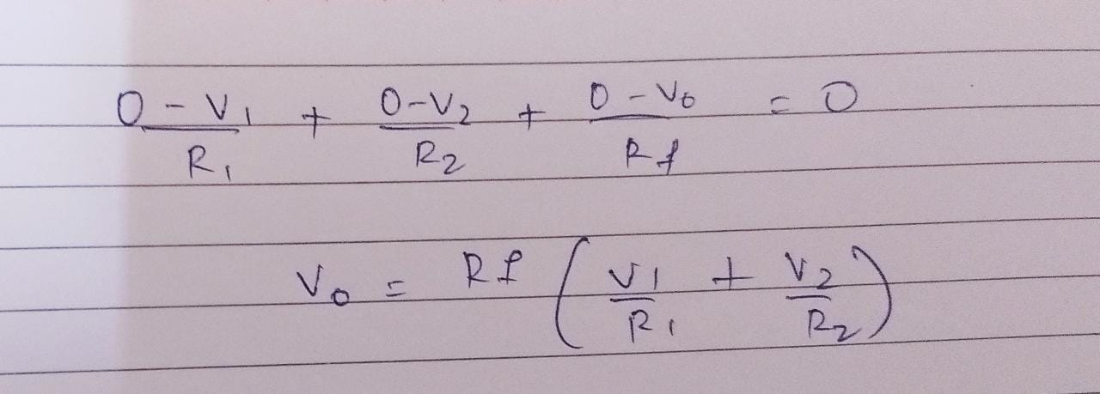

Therefore, the op-amp based adder circuit discussed above will produce the sum of the two input voltages, as the output, when all the resistors present in the circuit are of same value. Note that the output voltage V0 of an adder circuit is having a negative sign, which indicates that there exists a 180-degree phase difference between the input and the output.

**(2). Subtractor: -**

A subtractor is an electronic circuit that produces an output, which is equal to the difference of the applied inputs. This section discusses about the op-amp based subtractor circuit. An op-amp based subtractor produces an output equal to the difference of the input voltages applied at its inverting and non-inverting terminals. It is also called as a difference amplifier, since the output is an amplified one.

The circuit diagram of an op-amp based subtractor is shown in the following figure –

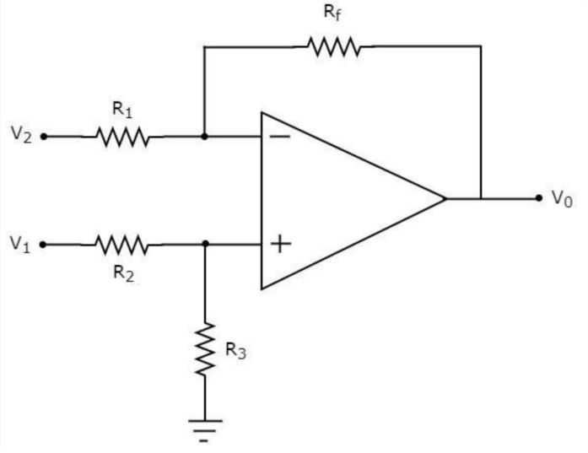

Firstly, let us calculate the output voltage Vo1 by considering only V1.

Then, let us calculate the output voltage Vo2 by considering only V2.

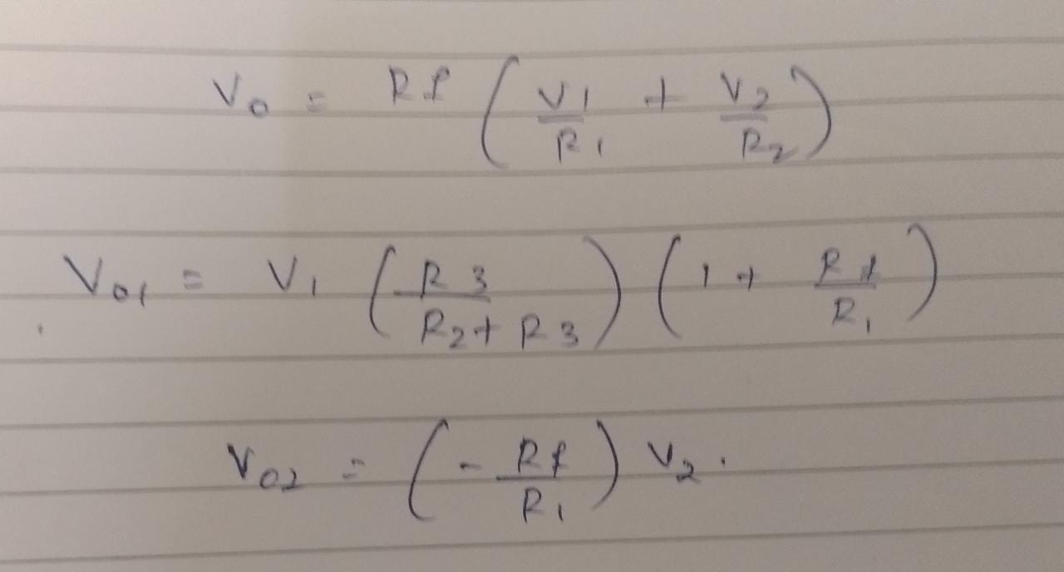

Sum of Vo1 + Vo2 = Vo

**(3). The Summing Amplifier: -**

The Summing Amplifier is another type of operational amplifier circuit configuration that is used to combine the voltages present on two or more inputs into a single output voltage.

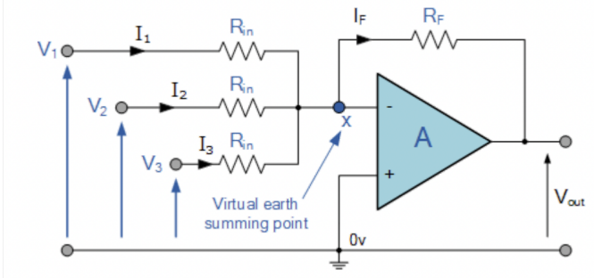

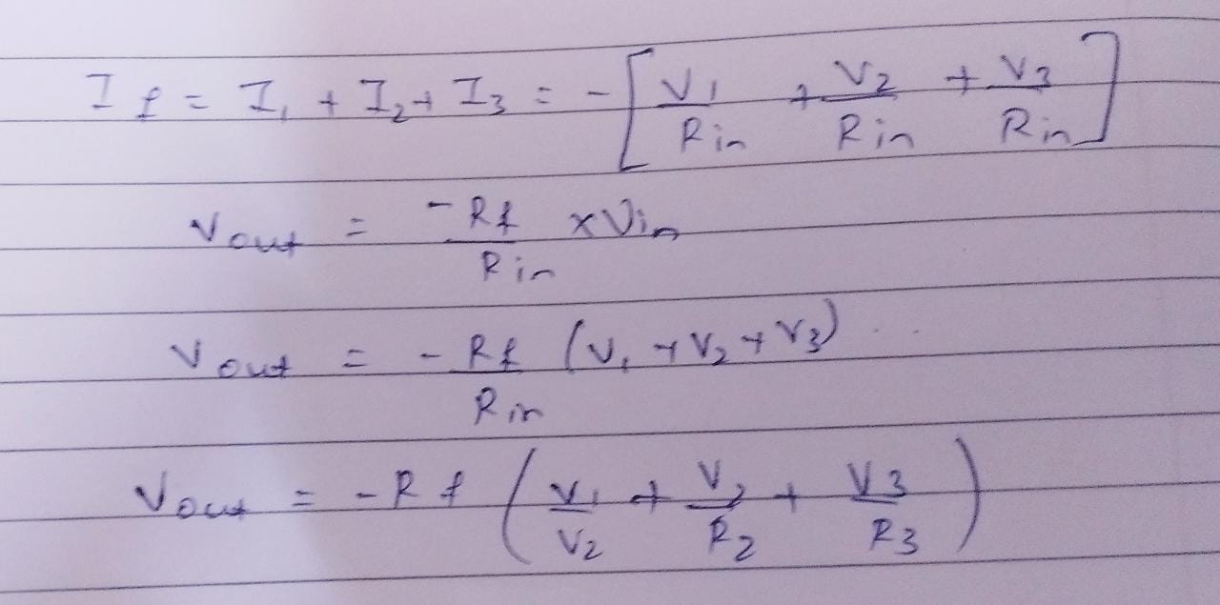

**(4). Op-amp Comparator Circuit: -**

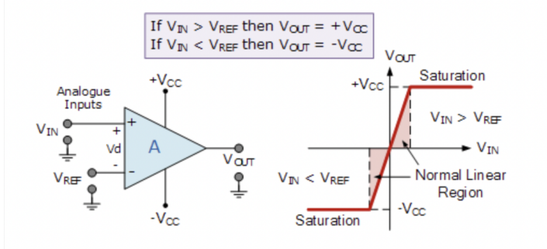

With reference to the op-amp comparator circuit above, lets first assume that VIN < VREF. As the non-inverting (positive) input of the comparator is less than the inverting (negative) input, the output will be LOW and at the negative supply voltage, -Vcc resulting in a negative saturation of the output.

If we now increase the input voltage, VIN > VREF on the inverting input, the output voltage rapidly switches HIGH towards the positive supply voltage, +Vcc resulting in a positive saturation of the output. If we reduce again the input voltage VIN, so that it is slightly less than the reference voltage, the op-amp’s output switches back to its negative saturation voltage acting as a threshold detector.

Then we can see that the op-amp voltage comparator is a device whose output is dependant on the value of the input voltage, VIN with respect to some DC voltage level as the output is HIGH when the voltage on the non-inverting input is greater than the voltage on the inverting input, and LOW when the non-inverting input is less than the inverting input voltage. This condition is true regardless of whether the input signal is connected to the inverting or the non-inverting input of the comparator.

We can also see that the value of the output voltage is completely dependent on the op-amps power supply voltage.

**(5). Integrator: -**

An integrator is an electronic circuit that produces an output that is the integration of the applied input. This section discusses about the op-amp based integrator. An op-amp based integrator produces an output, which is an integral of the input voltage applied to its inverting terminal. The circuit diagram of an op-amp based integrator is shown in the following figure –

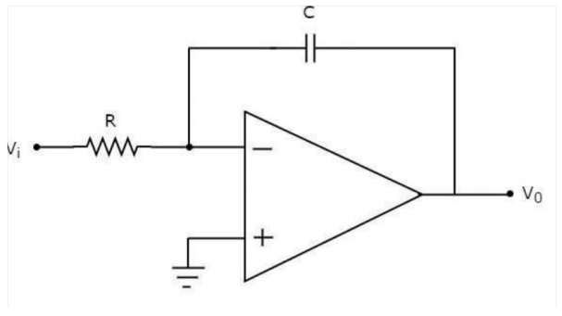

In the circuit shown above, the non-inverting input terminal of the op-amp is connected to ground. That means zero volts is applied to its non-inverting input terminal. According to virtual short concept, the voltage at the inverting input terminal of op-amp will be equal to the voltage present at its noninverting input terminal. So, the voltage at the inverting input terminal of op-amp will be zero volts. The nodal equation at the inverting input terminal is –

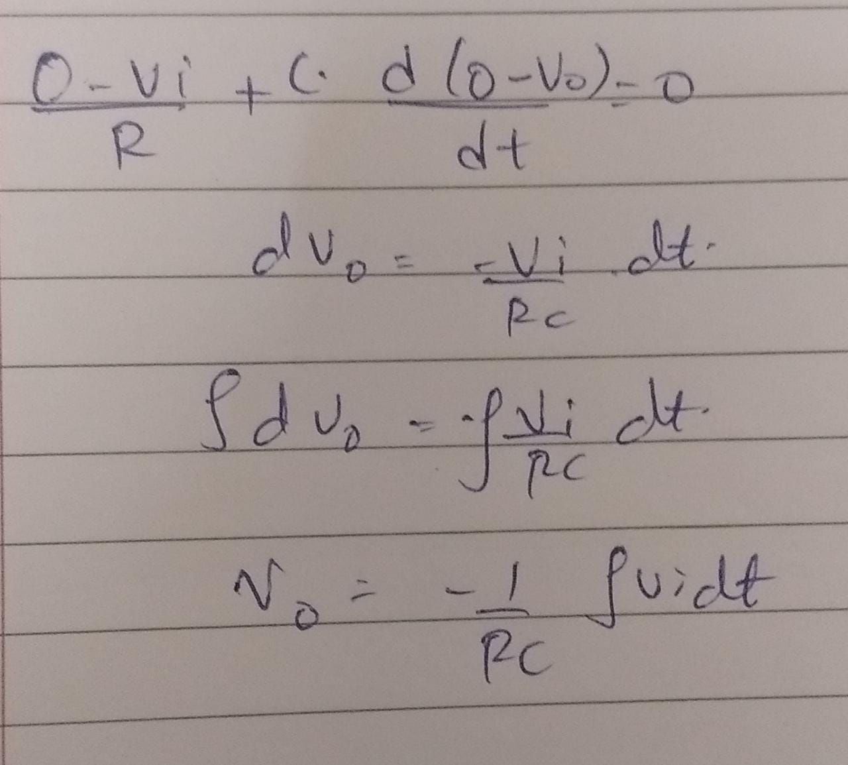

So, the op-amp based integrator circuit discussed above will produce an output, which is the integral of input voltage Vi, when the magnitude of impedances of resistor and capacitor are reciprocal to each other. Note − The output voltage, V0 is having a negative sign, which indicates that there exists 1800 phase difference between the input and the output.

**(6). Differentiator: -**

A differentiator is an electronic circuit that produces an output equal to the first derivative of its input. An op-amp based differentiator produces an output, which is equal to the differential of input voltage that is applied to its inverting terminal. The circuit diagram of an opamp based differentiator is shown in the following figure

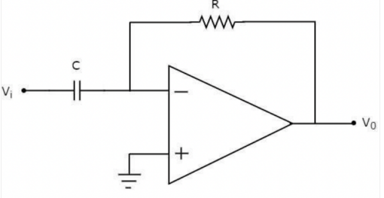

In the above circuit, the non-inverting input terminal of the op-amp is connected to ground. That means zero volts is applied to its noninverting input terminal. According to the virtual short concept, the voltage at the inverting input terminal of op-amp will be equal to the voltage present at its non-inverting input terminal. So, the voltage at the inverting input terminal of op-amp will be zero volts. The nodal equation at the inverting input terminal's node is –

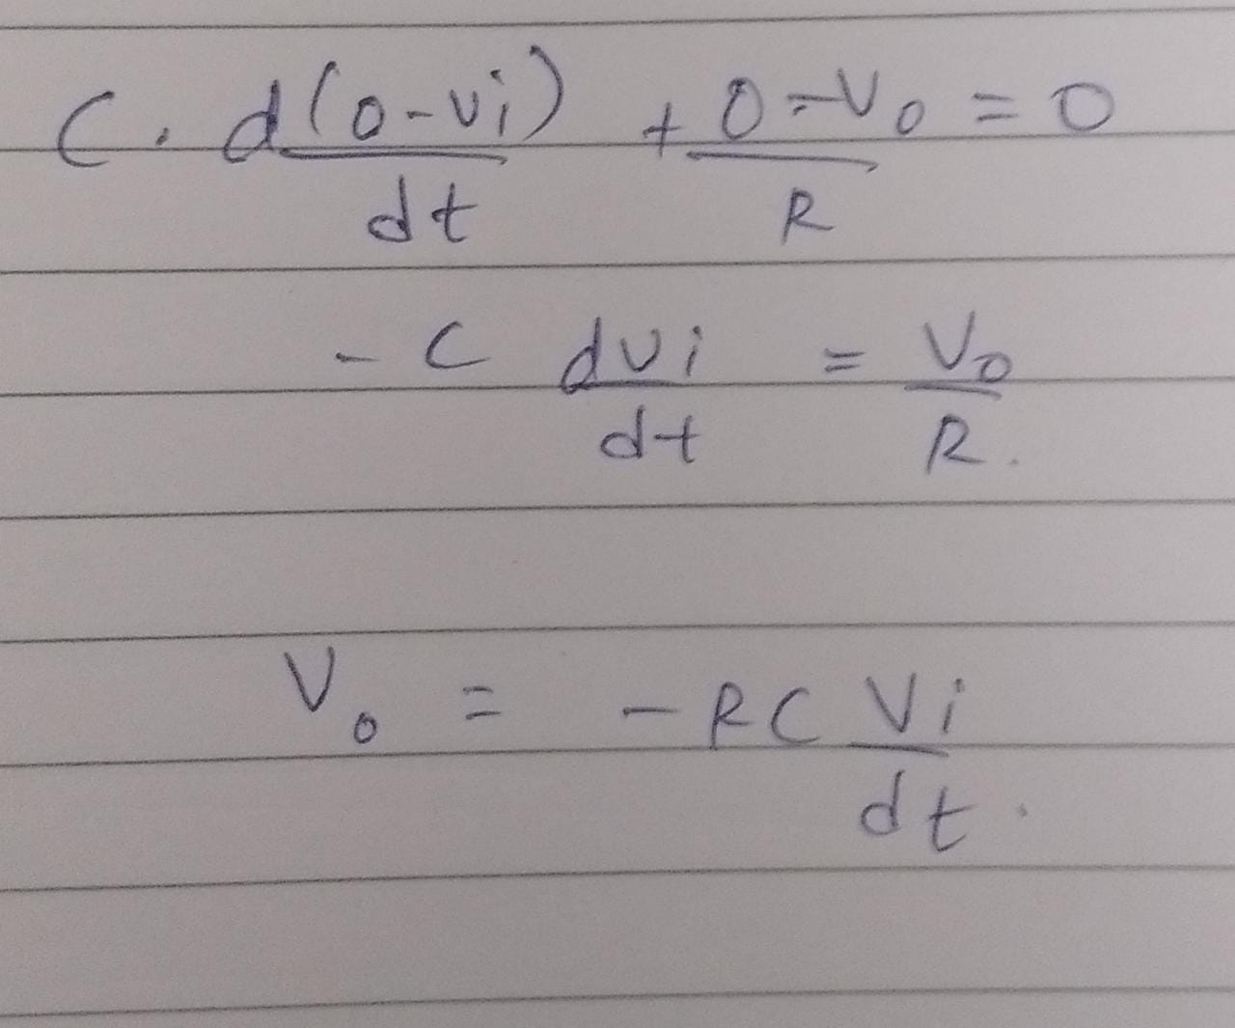

Thus, the op-amp based differentiator circuit shown above will produce an output, which is the differential of input voltage Vi, when the magnitudes of impedances of resistor and capacitor are reciprocal to each other. Note that the output voltage V0 is having a negative sign, which indicates that there exists a 180o phase difference between the input and the output.

**CIRCUIT/CONNECTION DIAGRAMS (FROM MULTISIM)**

**ALONG WAVEFORMS (FROM MULTISIM)**

**OP-AMP ADDER**

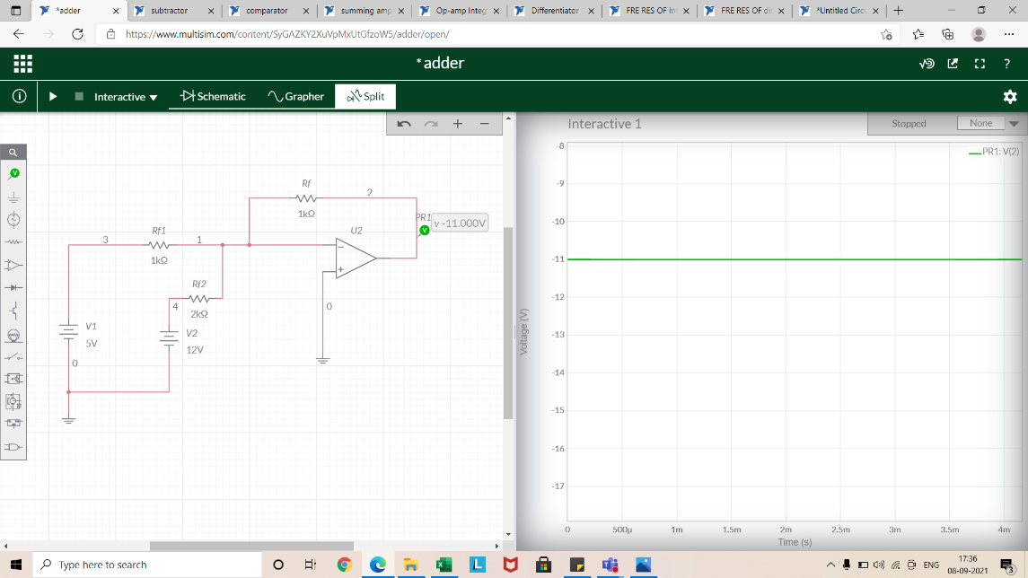

**CIRCUIT/CONNECTION DIAGRAMS (FROM MULTISIM)**

**ALONG WAVEFORMS (FROM MULTISIM)**

**OP-AMP SUBSTRACTOR**

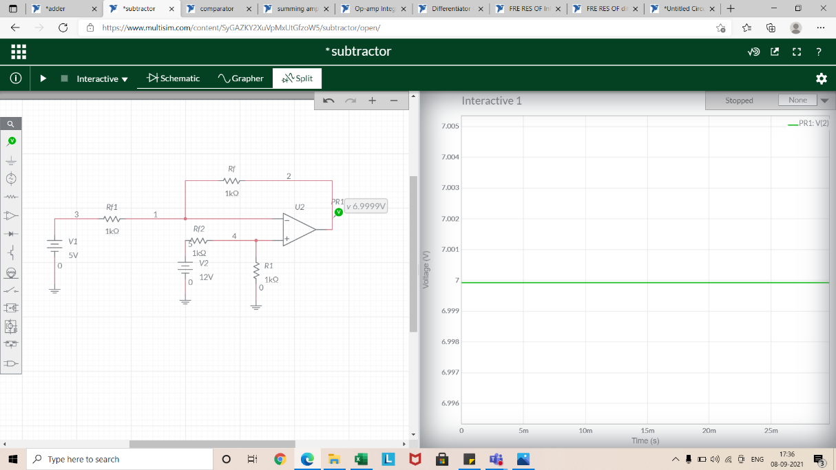

**CIRCUIT/CONNECTION DIAGRAMS (FROM MULTISIM)**

**ALONG WAVEFORMS (FROM MULTISIM)**

**OP-AMP SUMMING AMPLIFIER**

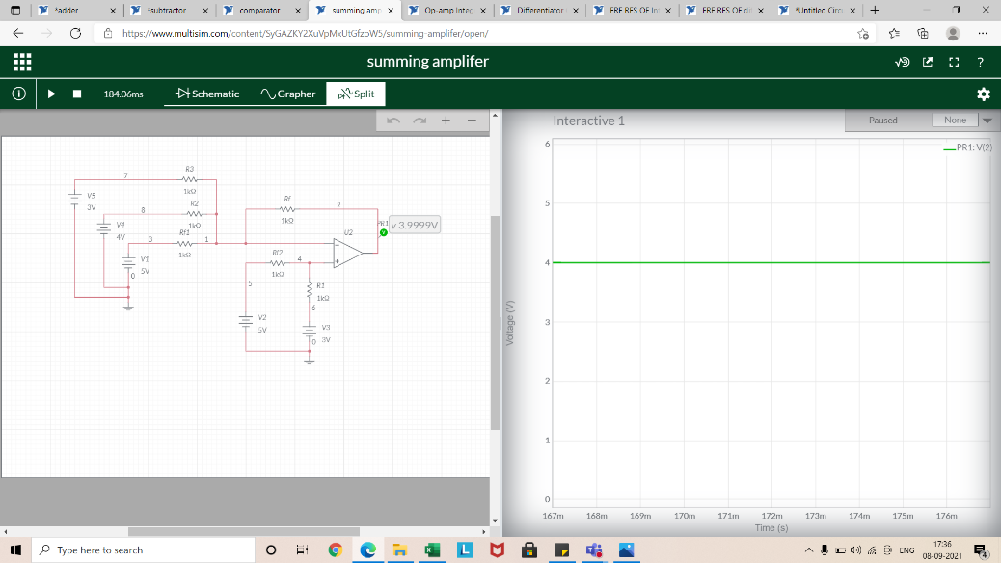

**CIRCUIT/CONNECTION DIAGRAMS (FROM MULTISIM)**

**ALONG WAVEFORMS (FROM MULTISIM)**

**OP-AMP COMPARATOR**

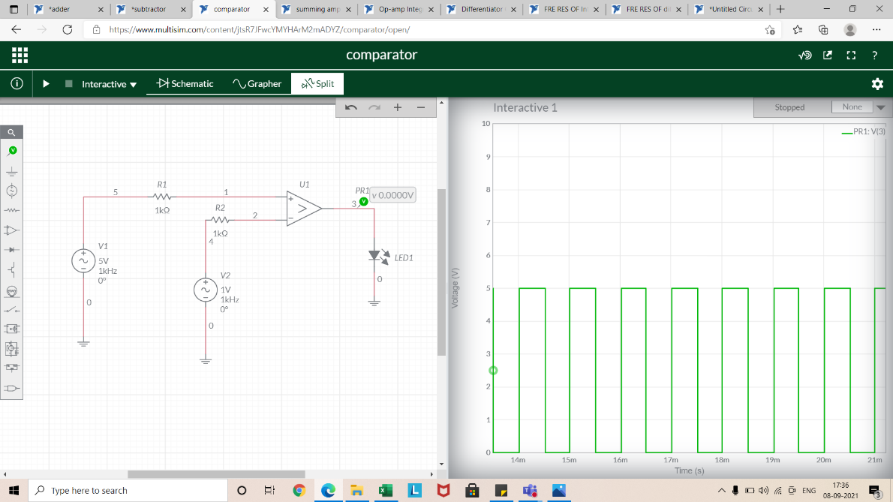

**CIRCUIT/CONNECTION DIAGRAMS (FROM MULTISIM)**

**ALONG WAVEFORMS (FROM MULTISIM)**

**OP-AMP INTEGRATOR**

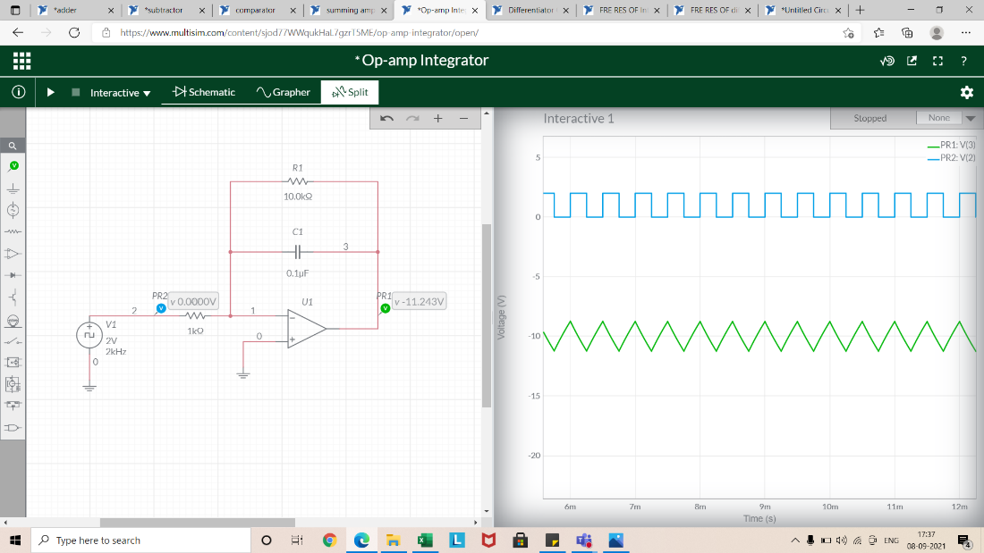

**CIRCUIT/CONNECTION DIAGRAMS (FROM MULTISIM)**

**ALONG WAVEFORMS (FROM MULTISIM)**

**OP-AMP DIFFRENTIATOR**

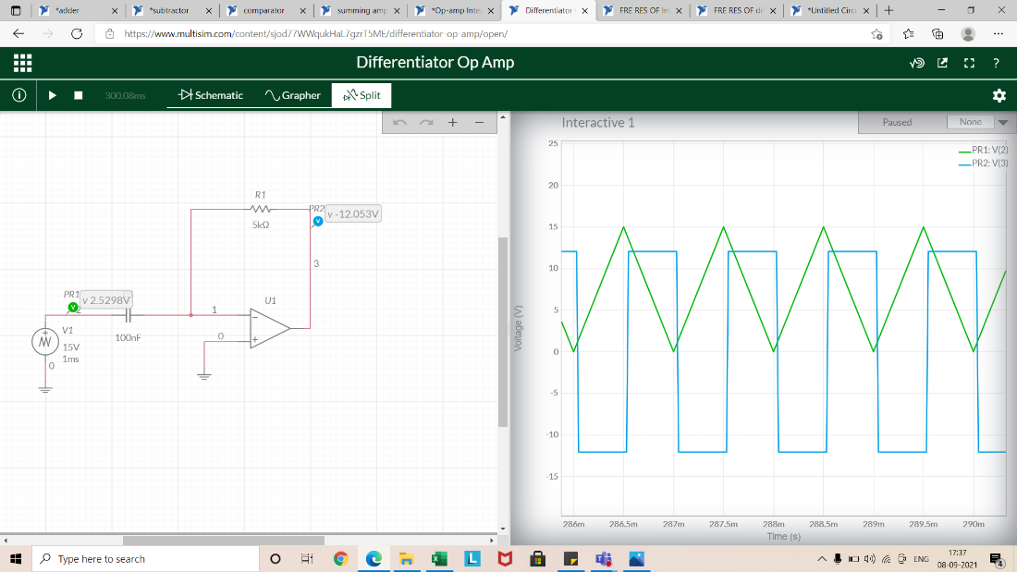

**CIRCUIT/CONNECTION DIAGRAMS (FROM MULTISIM)**

**ALONG WAVEFORMS (FROM MULTISIM)**

**FREQUENCY RESPONSE OF INTEGRATOR**

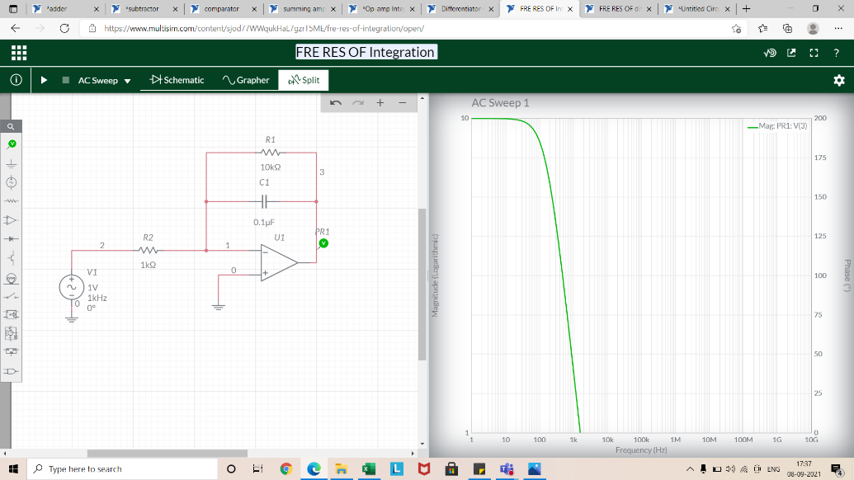

**CIRCUIT/CONNECTION DIAGRAMS (FROM MULTISIM)**

**ALONG WAVEFORMS (FROM MULTISIM)**

**FREQUENCY RESPONSE OF DIFFRENTIATO**

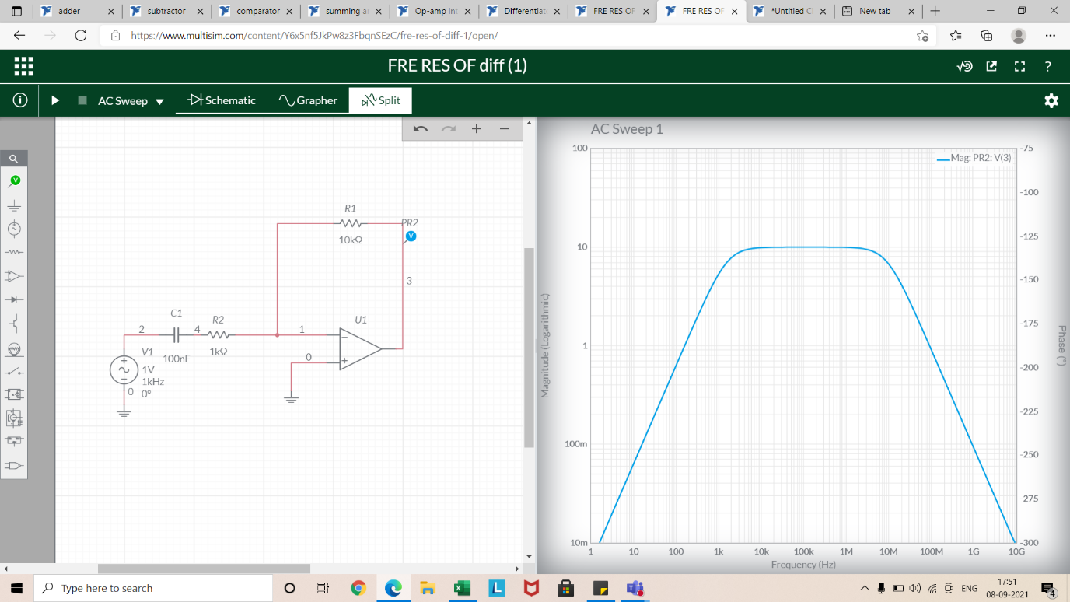

**Calculations:**

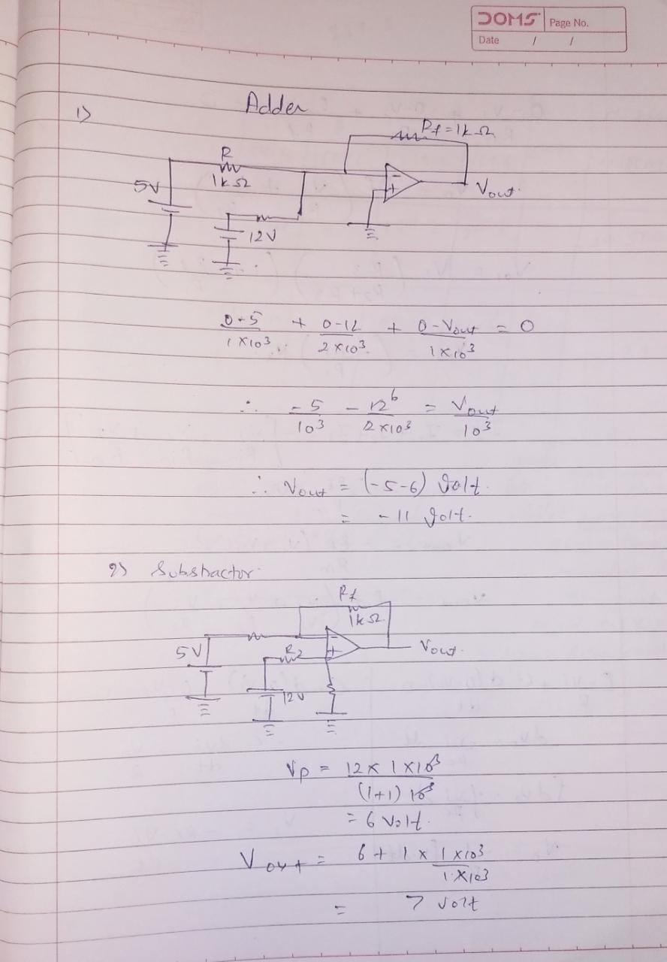

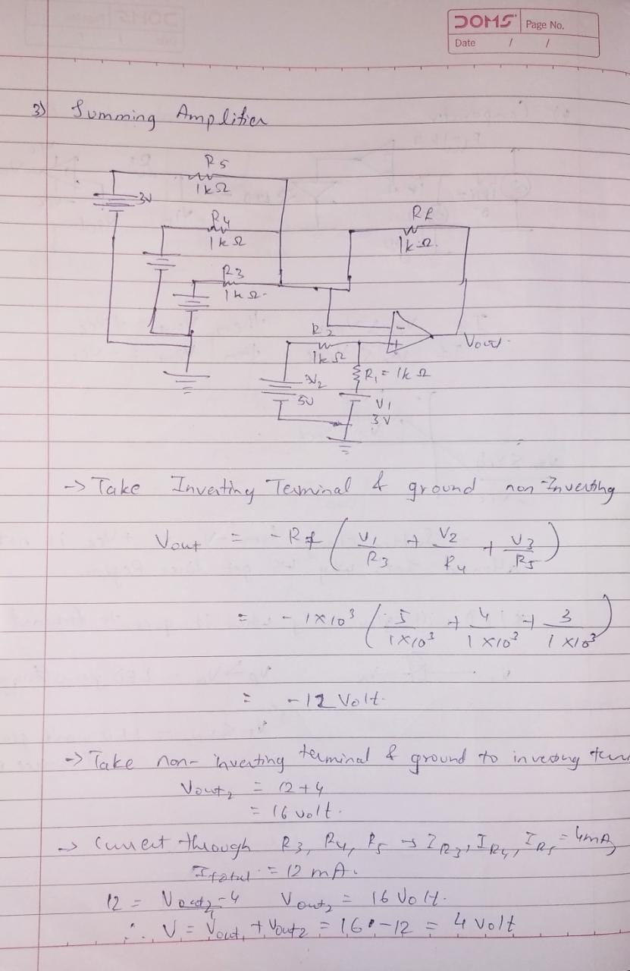

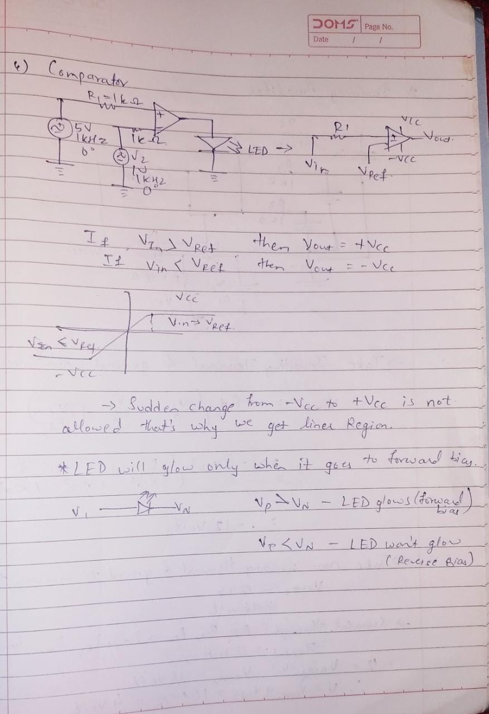

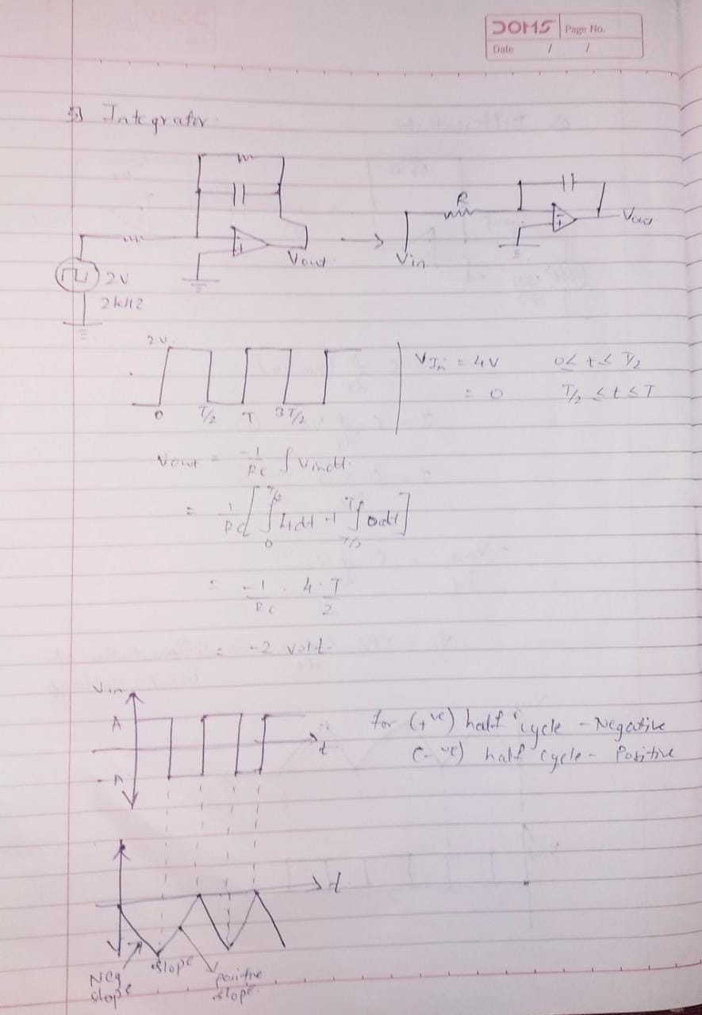

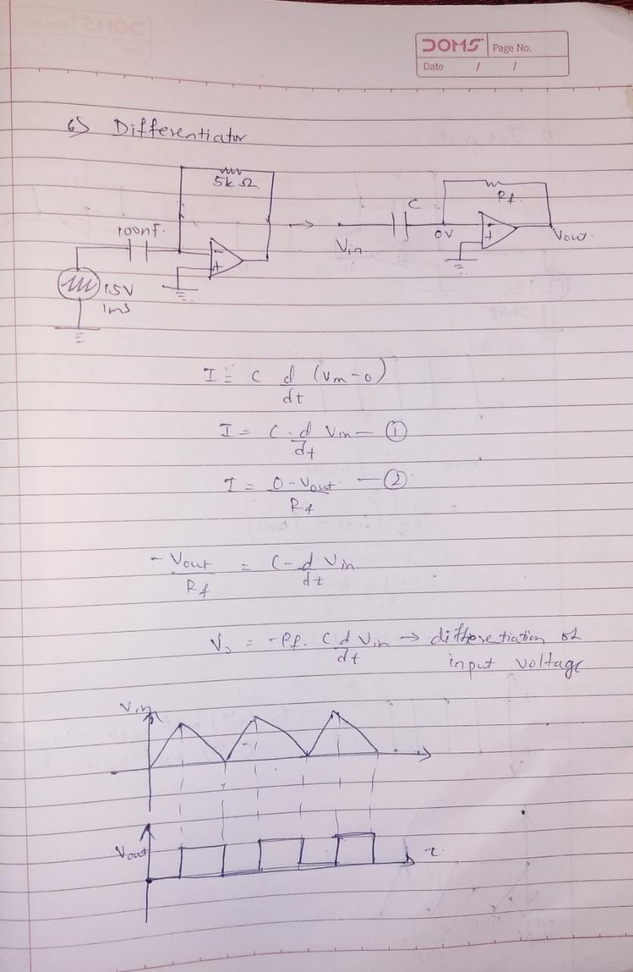

**CONCLUSION: -**

Here, Practical and Theoretical result of various OP-AMP circuits are same. Hence, Application of various OP-AMP circuits are verified.